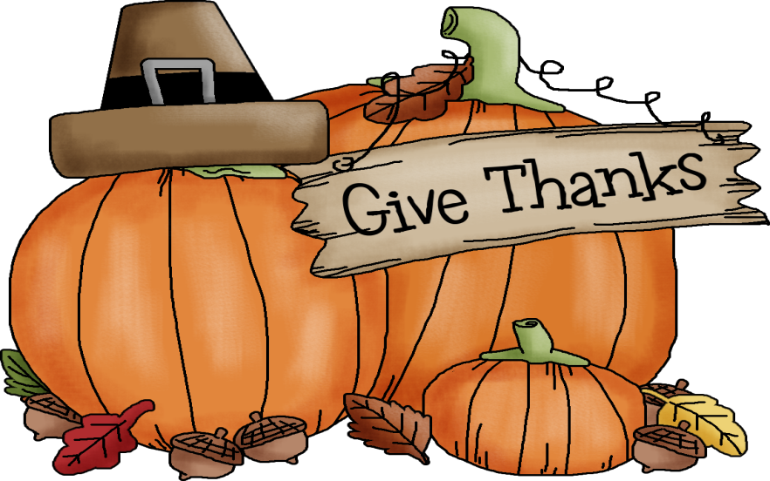

November 2026 GGPS Happenings
Sunday | Monday | Tuesday | Wednesday | Thursday | Friday | Saturday
1 | 2 | 3  No School | 4  Discovery Time | 5  Discovery Time | 6  Butter Braid sale ends. All forms returned by 9:30 am | 7
8 | 9 | 10  Little Hands, Big Thanks Family Event | 11  Little Hands, Big Thanks Family Event | 12 | 13 | 14
15 | 16 | 17  Spirit Day! Wear your Spirit Wear! | 18  Spirit Day!  Wear your Spirit Wear | 19 | 20 | 21
22 | 23  No School  Optional Parent Teacher Conference | 24  No School  Optional Parent Teacher Conference | 25  No School  Thanksgiving Break | 26  Happy Thanksgiving! | 27  No School Thanksgiving Break | 28
29 | 30

